**PROJECT DEVELOPMENT PHASE**

**SPRINT DELIVERY-3**

|  |  |
| --- | --- |
| Date | 10 November 2022 |
| Team ID | PNT2022TMID27179 |
| Project Name | Smart farmer- IoT based smart farming application |

**Configuration of Node-Red to send commands to IBM cloud**

*ibmiot out node I used to send data from Node-Red to IBM Watson device. So, after adding it to the flow we need*

*to configure it with credentials of our Watson device.*

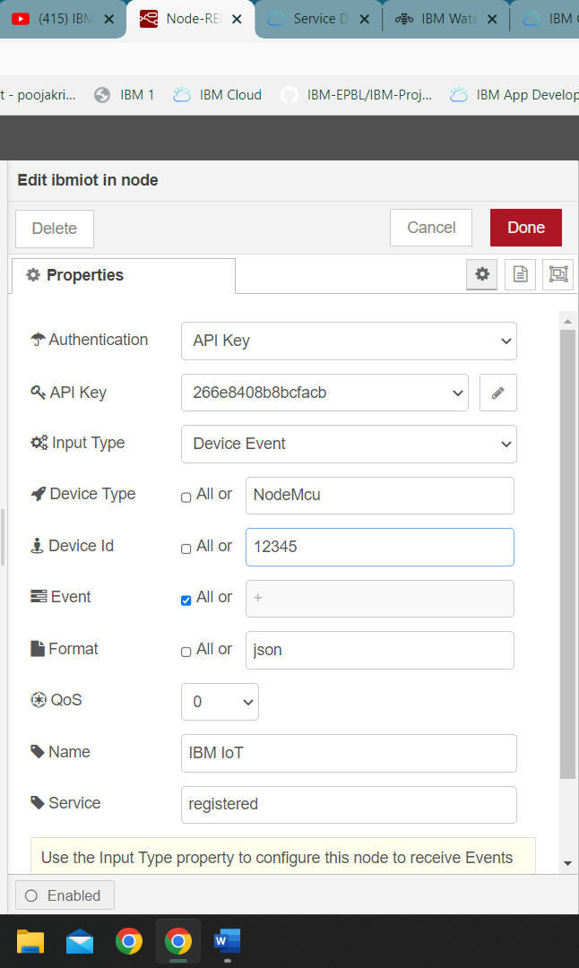

Here we add two buttons in UI

1 -> for motor on

2 -> for motor off

We used a function node to analyses the data received and assign command to each number. The Java script code

for the analyses is: if (msg. payload===1) msg. payload= {"command”: “ON"};

else if (msg. payload===0)

msg. payload= {"command”: “OFF"};

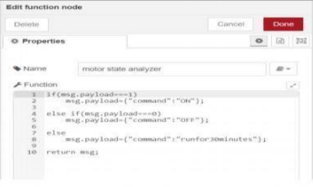

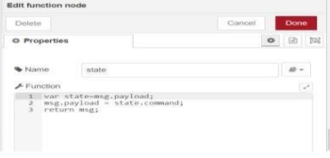

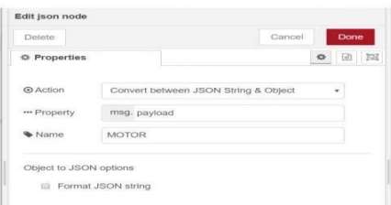

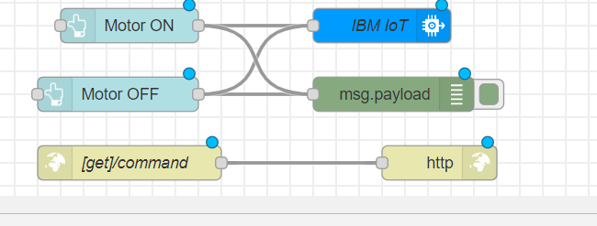

This is the program flow for sending commands to IBM cloud

*Complete Program Flow:*

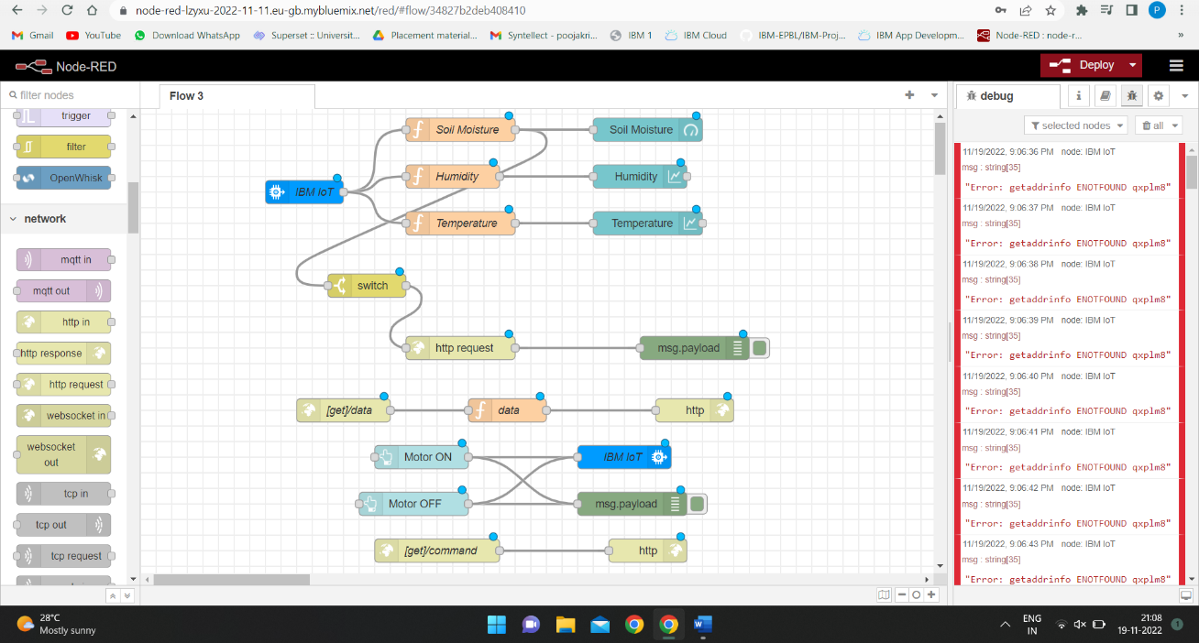

*MOBILE APP WEB:*

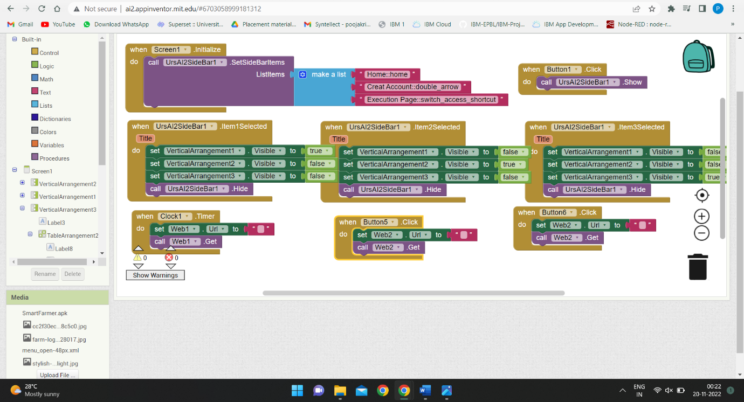

BLOCK DIAGRAM:

